# ASSIGNMENT OF HUMAN RESOURCE MANAGEMENT

# 

**Bachelor Of Science (Computer Science)**

**Submitted by:**

FATIMA SARFRAZ (2123110076)

**Session**

2021-2025

BSCS (7th SEMESTER)

**Submitted To:**

Miss Meerab Mahmood

DEPARMENT OF COMPUTER SCIENCE

GOVT POST GRADUATE COLLEGE (W) SAMANABAD, LAHORE

AFFITIALATED WITH

LAHORE COLLEGE FOR WOMEN UNIVERSITY ,LAHORE

**TOPICS NAMES:**

**Case Studies And Review Final Presentation :**

**Case 1-1 Employee Participation And Customer Satisfactions**

**Case 3-1 A Case Of Harassment In HRM**

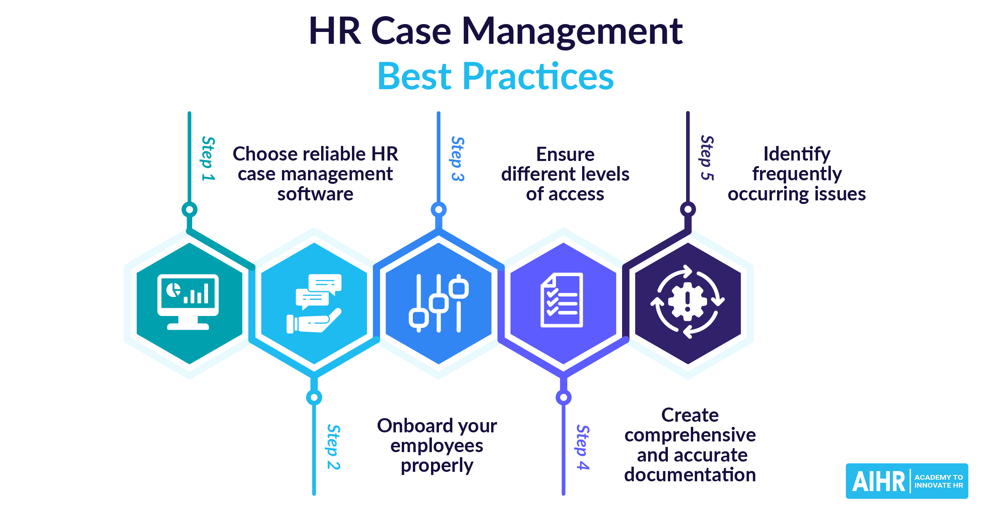

**Case Study: Employee Participation and Customer Satisfaction**

**in HRM (Case 1-1)**

This case study highlights the strong connection between employee participation and customer satisfaction within the framework of Human Resource Management. Initially, the organization was struggling with low customer satisfaction despite offering quality products and services. Customers often complained about poor service and unhelpful staff. At the same time, employees felt disengaged, unmotivated, and excluded from important decisions. To address this, the management introduced several HR strategies focused on employee involvement. These included suggestion systems where employees could share their ideas, participative management to involve staff in decision-making, and training programs to improve customer service skills. Continuous improvement teams were also formed to identify and solve customer service issues. As employees began to feel more valued and included, their morale and performance improved. They took greater responsibility for their roles and began treating customers more attentively. Over time, customer satisfaction scores improved significantly. This case demonstrates that when employees are empowered and actively engaged through thoughtful HR practices, they contribute more positively to the organization, leading to better service and higher customer satisfaction. It also emphasizes the strategic role of HR in aligning employee well-being with organizational success.

**Background:**

In today's competitive business environment, organizations are increasingly recognizing that **employee involvement** and **engagement** directly influence **customer satisfaction** and **business performance**. This case examines how an organization implemented employee participation strategies and how that led to improved customer satisfaction outcomes.

**Problem Statement:**

The company was facing stagnant or declining customer satisfaction levels. Despite having quality products/services, customers complained about poor service, unresponsive staff, and inconsistent experiences. Employees felt **disconnected, uninformed**, and **disempowered** in their roles.

**Objective of the Case:**

To explore how increasing employee participation and engagement in organizational processes can lead to:

* Higher employee motivation and productivity.
* Improved customer service and satisfaction.
* Stronger alignment between employee behavior and organizational goals.

**Key Concepts in HRM Highlighted**

* **Employee Involvement & Empowerment**
* **Participative Decision-Making**
* **Employee Engagement**
* **Customer-Oriented HR Strategies**
* **Performance Measurement and Feedback**

**Actions Taken by the Company**

* **Introduced Suggestion Systems**  
  Employees were encouraged to share ideas and suggestions for improving internal processes

and customer service. These suggestions were reviewed regularly by a committee.

* **Implemented Participative Management**  
  Employees from different departments were included in decision-making processes, especially

those impacting day-to-day operations and customer interactions.

* **Established Continuous Improvement Teams (CITs)**  
  Cross-functional teams were formed to identify and solve issues affecting customer satisfaction.
* **Conducted Training & Development Programs**  
  Focused on communication skills, customer service, and problem-solving techniques.
* **Created a Feedback Loop**  
  Customer feedback was regularly shared with employees to help them understand the impact

Of their work.

**Results and Outcomes**

1. **Improved Customer Satisfaction Metrics**
   * Customer service ratings increased.
   * Repeat customers and customer loyalty improved.
2. **Higher Employee Morale**
   * Employees felt more valued and part of the success of the organization.
   * Improved job satisfaction and reduced turnover.
3. **Operational Efficiency**
   * Employees helped identify bottlenecks and implemented practical solutions.
   * Process streamlining led to faster service delivery.
4. **Culture Shift**
   * From a top-down approach to a collaborative work environment.
   * Empowerment led to accountability and ownership among employees.

**Analysis Using HRM Theories**

| **HRM Theory/Model** | **Application in Case** |
| --- | --- |
| **Herzberg’s Two-Factor Theory** | Employee involvement served as a motivator, increasing job satisfaction. |
| **Maslow’s Hierarchy of Needs** | Participation helped fulfill esteem and self-actualization needs. |
| **High-Performance Work Systems (HPWS)** | Integration of training, participation, and feedback created synergy. |
| **Kirkpatrick’s Evaluation Model** | Training outcomes were measured by behavioral change and customer results. |

**Key Takeaways / Lessons Learned**

* **Employee satisfaction and customer satisfaction are closely linked.**
* **Empowering employees gives them a sense of purpose and ownership,** which translates into better performance.
* **HR plays a critical role** in designing and implementing systems that facilitateparticipation.
* **Organizational culture needs to support transparency, open communication, and collaboration to** sustain such programs.

**Conclusion**

This case clearly demonstrates that **employee involvement is not just an HR initiative, but a strategic business tool.** By enabling employees to take part in decision-making, organizations can **unlock innovative ideas**, improve employee morale, and directly impact **customer satisfaction and loyalty.** Effective HRM practices were at the heart of this transformation, showcasing the strategic value of human resources**.**

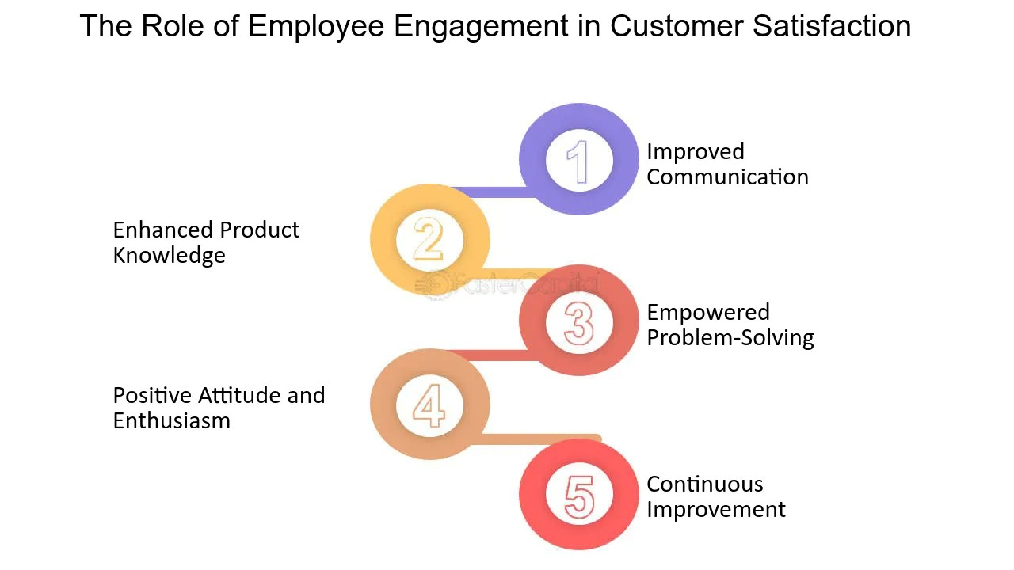

**Case 3-1 A Case Of Harassment In HRM**

In this case study, a female employee reports sexual harassment by her immediate supervisor, but the Human Resource department fails to take immediate and effective action. As a result, the employee feels unsupported, unsafe, and emotionally distressed, which negatively affects her mental well-being and work performance. The HR team’s slow and unstructured response highlights a serious lack of proper anti-harassment policies, training, and sensitivity in handling such issues. Although an investigation is eventually carried out, the delay causes the employee to lose trust in the organization, and she ultimately decides to resign. The situation also damages the company’s image and lowers employee morale. This case emphasizes the importance of having a clear, confidential, and accessible reporting system, along with timely HR intervention. It shows that workplace harassment must be taken seriously, and HR must play a proactive role in creating a respectful and safe environment for all employees.

**1. Background**

* A **female employee** files a **sexual harassment complaint** against her **male supervisor.**
* The accused holds significant **power** over the victim, complicating the situation.
* The **HR department** fails to respond quickly or appropriately to the complaint.
* The **employee’s emotional well-being** is negatively affected, and her work performance declines.

**2. HR’s Response**

* **Delayed response:** HR takes too long to act on the complaint.
* **Lack of a clear anti-harassment policy** and **inadequate training** for managers.
* **Power dynamics** make the situation harder for the employee to report and escalate.
* The **investigation** is slow, and the process lacks transparency.

**3. Results**

* **Employee resignation:** Due to emotional distress and lack of support, the employee decides to leave the organization.
* **Damaged reputation:** The company suffers from negative publicity and loss of employee trust.
* **Low morale**: Other employees begin to feel unsafe and lose trust in the management.

**4. Key HRM Insights**

* The **importance of a clear anti-harassment policy:** Preventive measures must be in place before issues arise.
* **HR’s role in protection:** HR must create an environment where employees feel safe and supported in reporting incidents.
* **Immediate action and confidentiality:** HR must respond swiftly, maintain confidentiality, and manage investigations fairly.
* **Training and awareness:** Regular employee and manager training on harassment and ethics are critical.

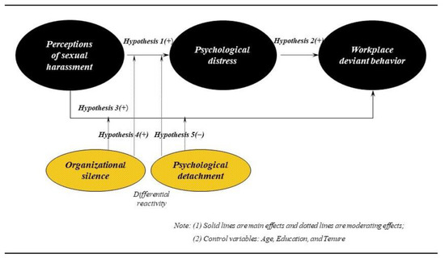

**Comparative Analysis of Both Cases**

**1. Common Themes**

* **Employee well-being** is central to organizational success.
* **HR’s role in shaping company culture:** Both cases show how HR can influence the work environment—either positively or negatively.

**2. Differences**

* **Case 1-1** focuses on proactive HR actions to increase **employee participation** and improve customer service.
* **Case 3-1** highlights the **failure of HR** to handle a harassment case properly, leading to negative consequences for both the employee and the organization.

**3. HR Best Practices (What we can learn)**

* **Proactive HR practices**: Like employee participation (Case 1-1) lead to better morale and customer satisfaction.
* **Reactive HR practices:** In handling complaints, such as harassment (Case 3-1), can have detrimental consequences if not managed effectively.

**Recommendations for HRM Practices**

* **For Case 1-1 (Employee Participation)**:
  + Encourage **employee involvement** in decision-making.
  + Provide **training programs** for both employees and managers to improve skills and customer service.
  + Create a system to **gather regular feedback** from employees and customers.
* **For Case 3-1 (Harassment)**:
  + Implement a **strong anti-harassment policy** and communicate it effectively across all levels.
  + Establish **confidential and safe reporting channels**.
  + Provide **regular training** on harassment prevention and ethical workplace behavior.
  + **Respond quickly** and ensure **transparency** in handling complaints to protect the organization and employees.

**Presentation Tips:**

* **Structure**:
  + Start with **Introduction.**
  + Present **each case** clearly with examples.
  + Provide **key insights** and **HR takeaways**.
  + End with **recommendations** and **discussion**.
* **Visuals**:
  + Use **before/after charts** for case results (e.g., employee engagement scores, customer satisfaction).
  + **Flowchart** to show how harassment complaints should be handled.
  + Use **bullet-point slides** to keep text minimal.
* **Engagement**:
  + Ask your audience: “How would you handle employee participation in your workplace?”
  + Pose a scenario: “What if you were the HR manager in Case 3-1, how would you act differently?”

**Conclusion:**

This case underscores the critical role of HR in preventing and addressing harassment. The failure of HR to respond promptly and appropriately led to emotional distress for the employee and reputational damage for the organization. A strong anti-harassment policy, clear reporting procedures, and regular training are essential for creating a safe and supportive workplace. HR must act quickly, fairly, and confidentially to protect employees and the organization from legal and ethical risks. In conclusion, proactive HR practices are key to fostering a respectful and safe work environment.